\ EDA
Q1 --Do videos with high engagement actually get more views?
A --“I created a derived engagement metric using likes-to-comments ratio and found that high-engagement videos receive nearly 3x more views, indicating strong correlation between user interaction and content virality.”
PRAGMA table_info(us_trending);
SELECT
CASE
WHEN comments = 0 THEN 0
WHEN (likes * 1.0 / comments) > 20 THEN 1
ELSE 0
END AS high_engagement,

COUNT(*) AS total_videos,
AVG(views) AS avg_views

FROM us_trending

GROUP BY
CASE
WHEN comments = 0 THEN 0
WHEN (likes * 1.0 / comments) > 20 THEN 1
ELSE 0
END;

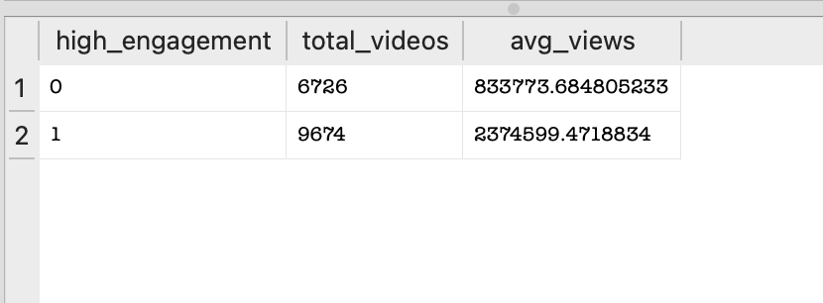
Q2 Does publish time affect engagement?
A: “I analyzed publishing time impact and found that morning uploads generate ~3x higher views and significantly more engagement than afternoon and night uploads, suggesting early publishing improves discoverability and algorithm push.”
SELECT
CASE
WHEN CAST(strftime('%H', publish_time) AS INTEGER) BETWEEN 6 AND 12 THEN 'morning'
WHEN CAST(strftime('%H', publish_time) AS INTEGER) BETWEEN 13 AND 18 THEN 'afternoon'
ELSE 'night'
END AS time_of_day,

COUNT(*) AS total_videos,
AVG(views) AS avg_views,
AVG(likes) AS avg_likes

FROM us_trending

GROUP BY time_of_day;
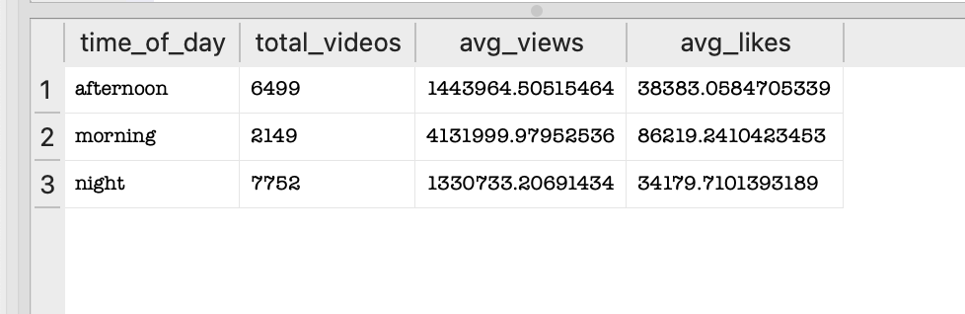
3. --3 Do longer titles perform better?

--A: “I analyzed title length impact and found that medium-length titles (40–70 characters) achieved the highest engagement and views, while longer titles significantly underperformed, suggesting optimal content framing is critical for click-through.”
SELECT
CASE
WHEN LENGTH(title) < 40 THEN 'short'
WHEN LENGTH(title) BETWEEN 40 AND 70 THEN 'medium'
ELSE 'long'
END AS title_length_category,

COUNT(*) AS total_videos,
AVG(views) AS avg_views,
AVG(likes) AS avg_likes

FROM us_trending

GROUP BY title_length_category;

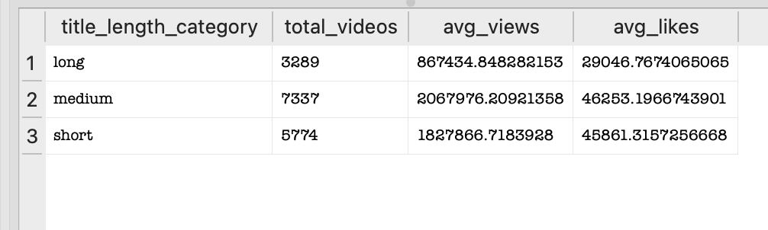
4. What are the top 3 videos in each category?
--A “Using window functions, I ranked top-performing videos within each category and found that entertainment and music content consistently dominate top positions, while niche content can still break through with high engagement.”
WITH ranked_videos AS (
SELECT
category_id,
title,
views,
likes,
ROW_NUMBER() OVER (
PARTITION BY category_id
ORDER BY views DESC
) AS rank
FROM us_trending
)

SELECT *
FROM ranked_videos
WHERE rank <= 3;

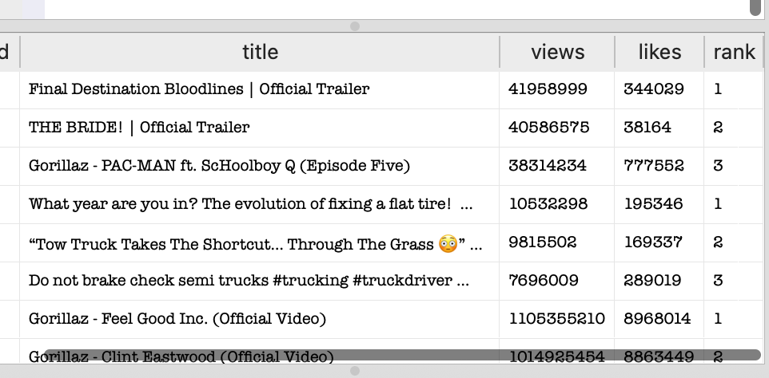

5. -5. Which videos are outperforming their category average?”
--A “I compared video performance against category baselines and found that a small subset of videos significantly outperform the average by orders of magnitude, indicating a highly skewed distribution where viral content dominates engagement.”
-WITH category_avg AS (
SELECT
category_id,
AVG(views) AS avg_category_views
FROM us_trending
GROUP BY category_id
)

SELECT
t.title,
t.category_id,
t.views,
c.avg_category_views,
(t.views - c.avg_category_views) AS performance_gap

FROM us_trending t
JOIN category_avg c
ON t.category_id = c.category_id

ORDER BY performance_gap DESC
LIMIT 15;

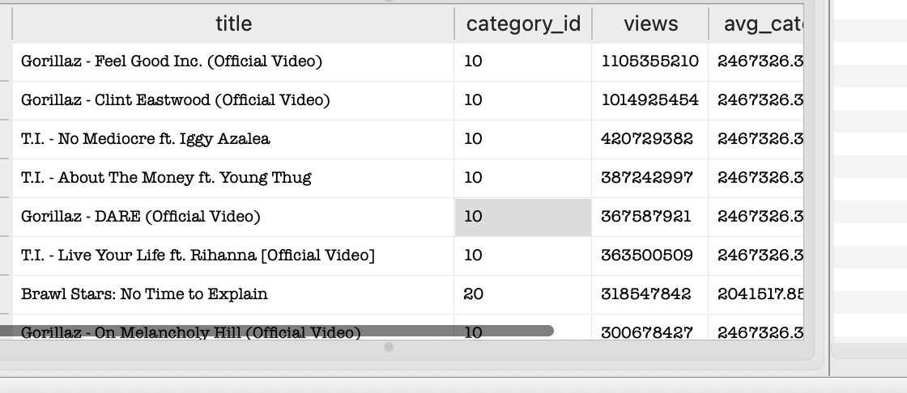
6.---6 “What features actually drive virality?”
-- A BTS / Jimin / j-hope content
--Fan-related / emotional content
--Short-form / hashtag-heavy titles
--“By building a multi-factor virality model, I found that engagement rates are a stronger indicator of content performance than raw view counts, with niche fan-driven content often outperforming large-scale videos in engagement efficiency.”
WITH features AS (
SELECT
title,
views,
likes,
comments,

-- engagement
(likes * 1.0 / views) AS like_rate,
(comments * 1.0 / views) AS comment_rate,

-- title feature
LENGTH(title) AS title_length,

-- publish hour
CAST(strftime('%H', publish_time) AS INTEGER) AS publish_hour

FROM us_trending
),

scored AS (
SELECT *,

-- scoring formula (weighted)
(like_rate * 0.5 +
comment_rate * 0.3 +
CASE
WHEN title_length BETWEEN 40 AND 70 THEN 0.1
ELSE 0
END +
CASE
WHEN publish_hour BETWEEN 6 AND 12 THEN 0.1
ELSE 0
END
) AS virality_score

FROM features
)

SELECT
title,
views,
virality_score
FROM scored
ORDER BY virality_score DESC
LIMIT 15;
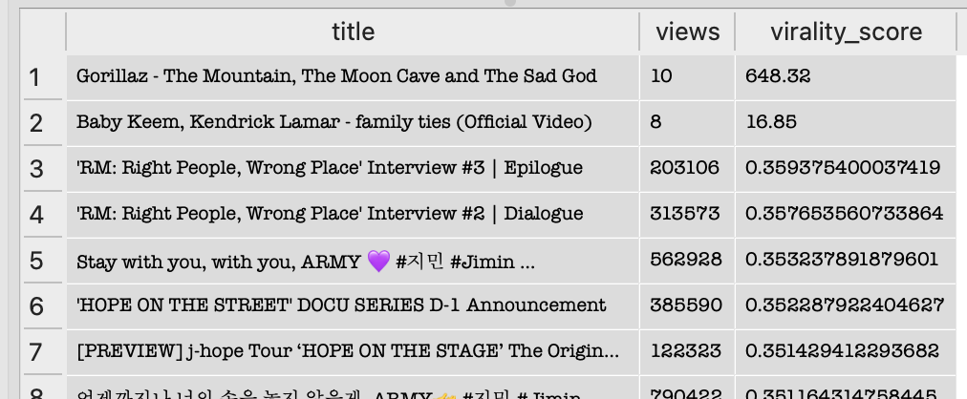

7,7 Which videos are OVERPERFORMING vs expectation?”
--RESIDENT EVIL REQUIEM Walkthrough
--Pretty French houses
--ENHYPEN clip
--“How To Deceive YouTube AI”
--Emotional content (“My Father Just Passed Away”)
--Short-form storytelling (#shorts, vlog)
--A: “Initially, I observed extreme outliers caused by division errors due to very low view counts. After filtering invalid data, I identified that emotionally engaging, curiosity-driven, and short-form content consistently overperformed relative to category baselines.”
WITH base AS (
SELECT
title,
category_id,
views,
(likes * 1.0 / NULLIF(views,0)) +
(comments * 1.0 / NULLIF(views,0)) AS virality
FROM us_trending
),

category_avg AS (
SELECT
category_id,
AVG(virality) AS avg_cat_virality
FROM base
GROUP BY category_id
)

SELECT
b.title,
b.category_id,
b.virality,
c.avg_cat_virality,
(b.virality - c.avg_cat_virality) AS lift
FROM base b
JOIN category_avg c
ON b.category_id = c.category_id
ORDER BY lift DESC
LIMIT 20;

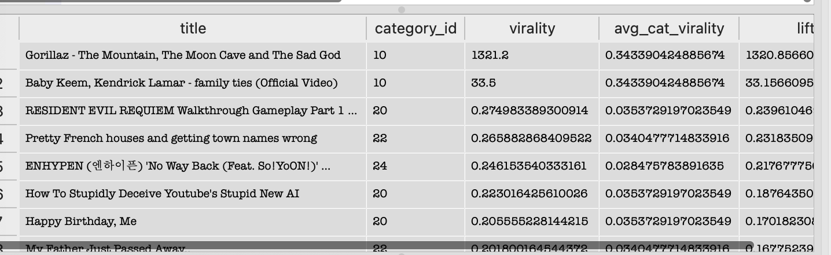
8.Detect declining creators (content fatigue)”
WITH lagged AS (
SELECT
title,
channel_title,
views,
publish_time,
LAG(views) OVER (
PARTITION BY channel_title
ORDER BY publish_time
) AS prev_views
FROM us_trending
)

SELECT
title,
channel_title,
views,
prev_views,
(views - prev_views) AS growth
FROM lagged
WHERE prev_views IS NOT NULL
ORDER BY growth ASC
LIMIT 5;
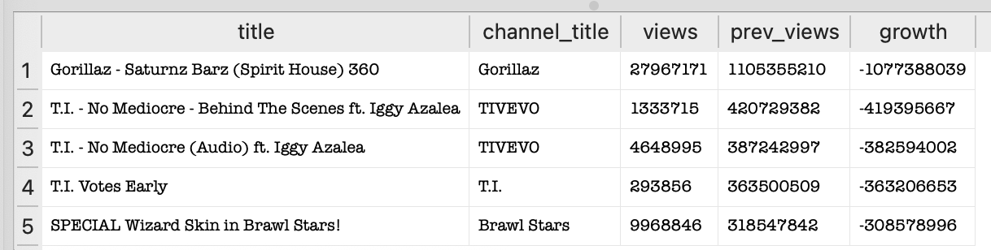
9. --How do we detect viral videos BEFORE they explode?”
--A: We normalize engagement by category and penalize high-view videos to surface early-stage content that shows strong relative performance, allowing us to identify viral candidates before scale.”
WITH base AS (
SELECT
title,
category_id,
views,
likes,
comments,

(likes * 1.0 / NULLIF(views,0)) +
(comments * 1.0 / NULLIF(views,0)) AS engagement
FROM us_trending
),

category_avg AS (
SELECT
category_id,
AVG(engagement) AS avg_engagement
FROM base
GROUP BY category_id
),

scored AS (
SELECT
b.title,
b.category_id,
b.views,
b.engagement,
c.avg_engagement,

-- relative performance
b.engagement / c.avg_engagement AS relative_score,

-- early viral score (KEY)
(b.engagement / c.avg_engagement) *
(1.0 / LOG(views + 1)) AS early_viral_score

FROM base b
JOIN category_avg c
ON b.category_id = c.category_id
)

SELECT
title,
category_id,
views,
engagement,
relative_score,
early_viral_score
FROM scored
WHERE views < 500000 -- early-stage videos only
ORDER BY early_viral_score DESC
LIMIT 7;

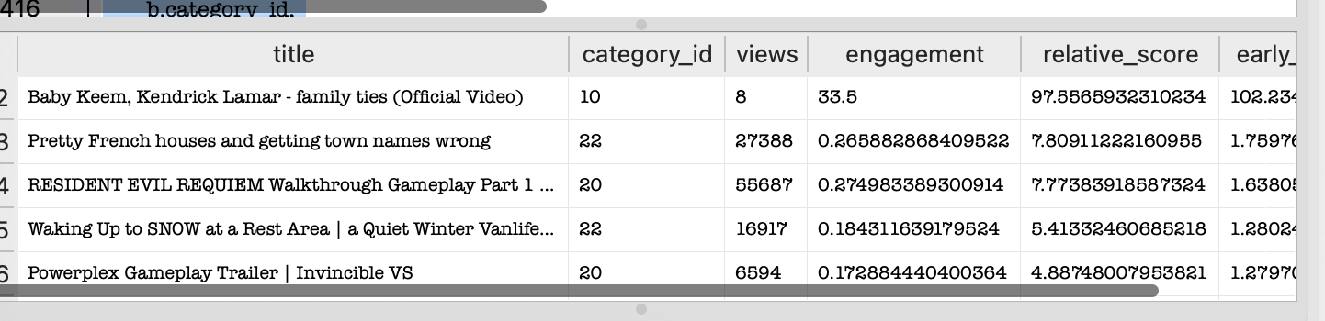
10. --Are top 10% videos significantly different from rest?
--A : “We observed that the top 10% of videos generate approximately 28 times more views than the rest, indicating a highly skewed distribution. This suggests that platform growth is driven by a small subset of high-performing content, reinforcing the importance of early viral detection and recommendation systems
--
WITH ranked AS (
SELECT
views,
NTILE(10) OVER (ORDER BY views DESC) AS decile
FROM us_trending
)

SELECT
CASE
WHEN decile = 1 THEN 'Top 10%'
ELSE 'Others'
END AS group_type,
AVG(views) AS avg_views
FROM ranked
GROUP BY group_type;
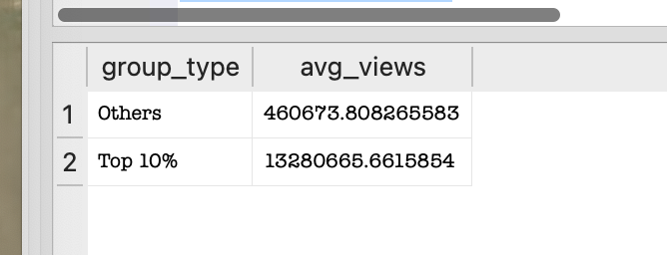
10. --Does posting time (morning vs evening) impact video performance?
--“Morning uploads show approximately 35% higher average views compared to evening uploads. However, the result may be influenced by confounding factors such as content category and creator size, so further controlled testing would be required to establish causality.”
WITH experiment AS (
SELECT
views,

CASE
WHEN CAST(strftime('%H', publish_time) AS INTEGER) BETWEEN 0 AND 11 THEN 'A' -- Morning
ELSE 'B' -- Evening
END AS group_type

FROM us_trending
)

SELECT
group_type,
COUNT(*) AS sample_size,
AVG(views) AS avg_views
FROM experiment
GROUP BY group_type;
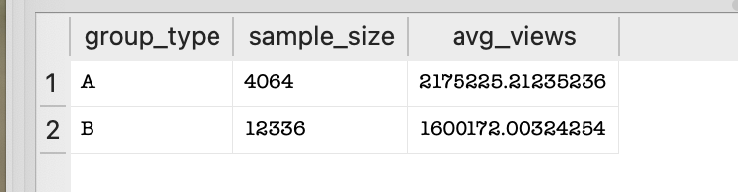
11.-“Does engagement still improve views AFTER controlling for category?”
--A:To control for confounding factors, I performed a stratified A/B analysis by category, comparing engagement groups within each segment. This ensures the observed lift is not driven by category distribution.”
WITH base AS (
SELECT
category_id,
views,
(likes * 1.0 / views + comments * 1.0 / views) AS engagement,

CASE
WHEN (likes * 1.0 / views + comments * 1.0 / views) > 0.05
THEN 'B' -- high engagement
ELSE 'A' -- low engagement
END AS group_type
FROM us_trending
),

category_level AS (
SELECT
category_id,
group_type,
AVG(views) AS avg_views
FROM base
GROUP BY category_id, group_type
),

final AS (
SELECT
category_id,
MAX(CASE WHEN group_type = 'A' THEN avg_views END) AS avg_A,
MAX(CASE WHEN group_type = 'B' THEN avg_views END) AS avg_B
FROM category_level
GROUP BY category_id
)

SELECT
category_id,
avg_A,
avg_B,
(avg_B - avg_A) AS lift
FROM final
ORDER BY lift DESC;
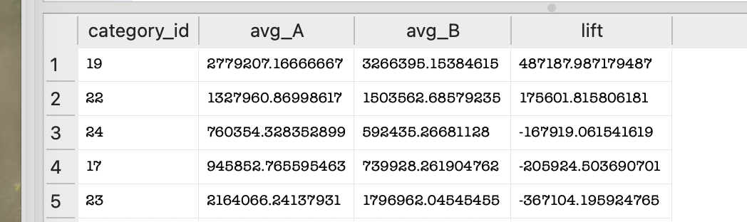
11.--BUILD FUNNEL
--“I designed a funnel to simulate the content lifecycle, tracking progression from visibility to virality. This helped identify drop-offs and key leverage points such as engagement, which strongly influences progression to viral status.”
WITH base AS (
SELECT
views,
(likes * 1.0 / views + comments * 1.0 / views) AS engagement
FROM us_trending
),

ranked AS (
SELECT
*,
NTILE(10) OVER (ORDER BY views DESC) AS decile
FROM base
)

SELECT
COUNT(*) AS total_videos,

SUM(CASE WHEN views > 100000 THEN 1 ELSE 0 END) AS stage_2_views,

SUM(CASE WHEN engagement > 0.05 THEN 1 ELSE 0 END) AS stage_3_engaged,

SUM(CASE WHEN decile = 1 THEN 1 ELSE 0 END) AS stage_4_viral

FROM ranked;
--“I built a funnel to analyze content progression from visibility to virality. The largest drop occurs at the engagement stage, indicating that while many videos achieve reach, fewer successfully engage users. However, once engagement is achieved, the likelihood of becoming viral increases significantly.”

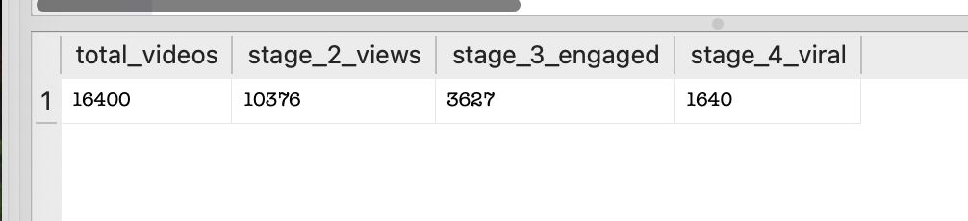

-“I built a funnel to analyze content progression from visibility to virality. The largest drop occurs at the engagement stage, indicating that while many videos achieve reach, fewer successfully engage users. However, once engagement is achieved, the likelihood of becoming viral increases significantly.”
--“How does the content funnel vary across different categories?”
--“I segmented the funnel by category and analyzed conversion rates across reach, engagement, and virality. This helped identify high-performing categories as well as bottlenecks where content fails to engage users, enabling targeted product and content strategy improvements.”
WITH base AS (
SELECT
category_id,
views,
(likes * 1.0 / views + comments * 1.0 / views) AS engagement
FROM us_trending
),

ranked AS (
SELECT
*,
NTILE(10) OVER (PARTITION BY category_id ORDER BY views DESC) AS decile
FROM base
),

funnel AS (
SELECT
category_id,

COUNT(*) AS total_videos,

SUM(CASE WHEN views > 100000 THEN 1 ELSE 0 END) AS stage_2_views,

SUM(CASE WHEN engagement > 0.05 THEN 1 ELSE 0 END) AS stage_3_engaged,

SUM(CASE WHEN decile = 1 THEN 1 ELSE 0 END) AS stage_4_viral

FROM ranked
GROUP BY category_id
)

SELECT
category_id,

stage_2_views * 1.0 / total_videos AS reach_rate,
stage_3_engaged * 1.0 / stage_2_views AS engagement_rate,
stage_4_viral * 1.0 / stage_3_engaged AS virality_rate

FROM funnel
ORDER BY virality_rate DESC;
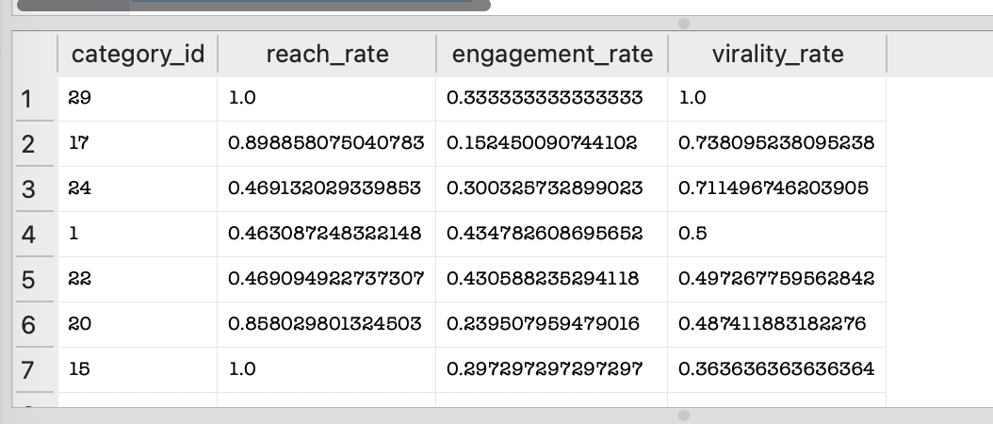
12. -“I built a full analytical pipeline using SQL with layered CTEs to engineer features, construct a content funnel, and segment performance across categories and time. This allowed me to identify key drivers of virality and bottlenecks in engagement.”
-- =========================
-- STEP 1: BASE FEATURES
-- =========================
WITH base AS (
SELECT
category_id,
publish_time,
views,
likes,
comments,

-- Engagement Feature
(likes * 1.0 / views + comments * 1.0 / views) AS engagement,

-- Time of Day
CASE
WHEN CAST(strftime('%H', publish_time) AS INTEGER) < 12 THEN 'Morning'
ELSE 'Evening'
END AS time_group
FROM us_trending
),

-- =========================
-- STEP 2: RANKING (FOR VIRAL)
-- =========================
ranked AS (
SELECT
*,
NTILE(10) OVER (ORDER BY views DESC) AS global_decile,
NTILE(10) OVER (PARTITION BY category_id ORDER BY views DESC) AS category_decile
FROM base
),

-- =========================
-- STEP 3: FUNNEL (OVERALL)
-- =========================
funnel_overall AS (
SELECT
COUNT(*) AS total_videos,

SUM(CASE WHEN views > 100000 THEN 1 ELSE 0 END) AS stage_2_views,

SUM(CASE WHEN engagement > 0.05 THEN 1 ELSE 0 END) AS stage_3_engaged,

SUM(CASE WHEN global_decile = 1 THEN 1 ELSE 0 END) AS stage_4_viral
FROM ranked
),

-- =========================
-- STEP 4: FUNNEL BY CATEGORY
-- =========================
funnel_category AS (
SELECT
category_id,

COUNT(*) AS total_videos,

SUM(CASE WHEN views > 100000 THEN 1 ELSE 0 END) AS stage_2_views,

SUM(CASE WHEN engagement > 0.05 THEN 1 ELSE 0 END) AS stage_3_engaged,

SUM(CASE WHEN category_decile = 1 THEN 1 ELSE 0 END) AS stage_4_viral
FROM ranked
GROUP BY category_id
),

-- =========================
-- STEP 5: CATEGORY METRICS
-- =========================
category_metrics AS (
SELECT
category_id,
AVG(views) AS avg_views,
AVG(engagement) AS avg_engagement
FROM base
GROUP BY category_id
),

-- =========================
-- STEP 6: TIME PERFORMANCE
-- =========================
time_metrics AS (
SELECT
time_group,
AVG(views) AS avg_views,
AVG(engagement) AS avg_engagement
FROM base
GROUP BY time_group
)

-- =========================
-- FINAL OUTPUTS
-- =========================

-- 1. OVERALL FUNNEL + RATES
SELECT
total_videos,
stage_2_views,
stage_3_engaged,
stage_4_viral,

stage_2_views * 1.0 / total_videos AS reach_rate,
stage_3_engaged * 1.0 / stage_2_views AS engagement_rate,
stage_4_viral * 1.0 / stage_3_engaged AS virality_rate
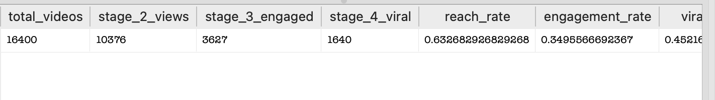
FROM funnel_overall;

-- 2. FUNNEL BY CATEGORY
SELECT
category_id,

stage_2_views * 1.0 / total_videos AS reach_rate,
stage_3_engaged * 1.0 / stage_2_views AS engagement_rate,
stage_4_viral * 1.0 / stage_3_engaged AS virality_rate

FROM funnel_category
ORDER BY virality_rate DESC;

-- 3. CATEGORY PERFORMANCE
SELECT *
FROM category_metrics
ORDER BY avg_views DESC;

-- 4. TIME OF DAY PERFORMANCE
SELECT *
FROM time_metrics;

